遇到困難:

1. 在執行test code時，出現無法找到log file的error，解決辦法是要先執行experiment file裡面的create-dir-script，讓每個file裡面都生成相對應的資料夾。
2. 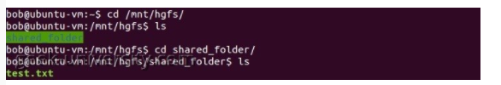Shared_folder:
3. 是不是不用分割檔案，直接丟整個大的file進去跑就好?
4. 跑一次 $X={10}^{6}, Y=100$ 的要多久?

* NOTE:

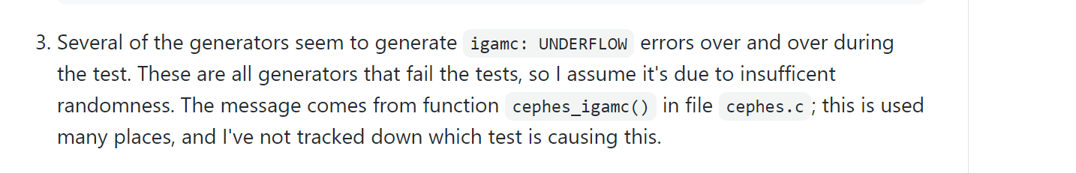

Parameter Selection:

1. Frequency (Monobit) Test:

* Input size:

$$n>100bits$$

1. Frequency Test within a Block:

* Parameters:

M: The length of each block.

n: The length of the bit string

$N=\left\lfloor \frac{n}{M}\right\rfloor$ (The number of blocks.)

* Input size:

$$n>100bits$$

$$n≥MN$$

$$M≥20 and M>0.01n$$

$$N<100$$

$$取N=80, n={10}^{6}→M=\frac{n}{N}=\frac{{10}^{6}}{80}=12500$$

$$符合 M>0.01×{10}^{6}=10000$$

1. Runs Test:

* Input size:

$$n>100bits$$

1. Test for the Longest Run of Ones in a Block:

* Input size:

$$n>7.5×{10}^{5}bits$$

1. Binary Matrix Rank Test:

* Input size:

$$n≥38MQ=38×32×32=38912bits$$

1. Discrete Fourier Transform (Spectral) Test

* Input size:

$$n>1000bits$$

1. Non-overlapping Template Matching Test:

* Parameters:

m: The length in bits of each template. The template is the target string.

n: The length of the entire bit string under test.

ε: The sequence of bits as generated by the RNG or PRNG being tested; this exists as a global structure at the time of the function call;

* Input size:

m = 9 or 10 for meaningful results.

N=8(specified in the test code, N<100)

1. Overlapping Template Matching Test:

* Input size:

m = 9 or 10 for meaningful results.

1. Maurer’s “Universal Statistical” Test: *(L不用設定嗎)

* Input size: L=7

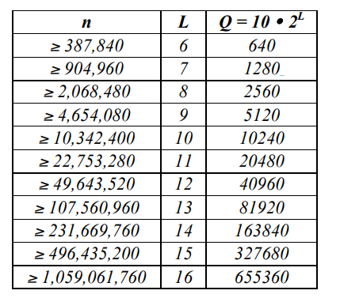

1. Linear Complexity Test:

* Parameter:

M: The length in bits of a block.

n: The length of the bit string

* Input size:

$$n>{10}^{6}$$

$$500≤M≤5000 and N≥200$$

$for chi-square result to be valid$

$$Let M=1000 and n={10}^{6} (same as example)$$

1. Serial Test:

* Parameter:

m: The length in bits of each block.

n: The length in bits of the bit string.

* Input size:

$$choose m and n such that m<\left\lfloor \log_{2}{n}-2\right\rfloor$$

$$Let m=10 and n={10}^{6},$$

$$which satisfy m< \left\lfloor \log_{2}{n}-2\right\rfloor = \left\lfloor \log_{2}{{10}^{6}}-2\right\rfloor =17$$

1. Approximate Entropy Test:

* Parameter:

m: The length of each block – in this case, the first block length used in the test. m+1 is the second block length used.

* Input size:

$$choose m and n such that m<\left\lfloor \log_{2}{n}-5\right\rfloor =14$$

$$Let m=10 and n={10}^{6}c can satisty requirements$$

1. Cumulative Sums (Cusum) Test:

* Input size:

$$n≥100bits$$

1. Random Excursions Test:

* Input size:

$$n≥{10}^{6}bits$$

1. Random Excursions Variant Test:

* Input size:

$$n≥{10}^{6}bits$$

REF:

<https://www.itread01.com/p/170336.html>

我目前的作法是寫了一個.sh的script去跑100個file，然後每次把finalAnalysisReport.txt儲存起來，所以總共會有100個這種report，想問助教說我目前這樣做法是否正確?